“Gikinoo’wizhiwe Onji Waaban (Guiding for Tomorrow) Changing Climate, Changing Culture

or “G-WOW” Initiative

A Model and Tools for Increasing Climate Change Literacy and Action

Do culture and science agree that climate change is real? What can we do about it?

“G-WOW” is a unique service learning model for increasing climate change literacy for middle school to adult learners. G-WOW integrates scientific research with place-based evidence of how climate change is affecting cultural and economic practices we value. G-WOW uses climate impacts on traditional “lifeways” of the Lake Superior Ojibwe to demonstrate place-based evidence of how climate change affects all of us. The project’s service learning approach promotes community level action to fight climate change. The G-WOW model can be adapted to other cultures and locations. We invite you to use these G-WOW outreach tools:
G-WOW Service Learning Website (www.g-wow.org)
This interactive website and curriculum explores how climate change is affecting our cultures and communities through its impact on traditional Ojibwe lifeways and water. Four seasonal lifeway units integrate traditional ecological knowledge, Ojbwe language, and place-based evidence of climate change with scientific climate research. Using activity guides, learners can develop their own climate change hypothesis and create a service learning climate activity. Project results can be shared via the website’s “Talking Circle” blog. The website’s features resource links, videos, interactive maps, service learning templates, lesson plans, experiential activities, and games that challenge learners to determine if culture and science agree that climate change is affecting all cultures while promoting climate action.
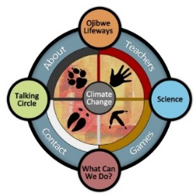

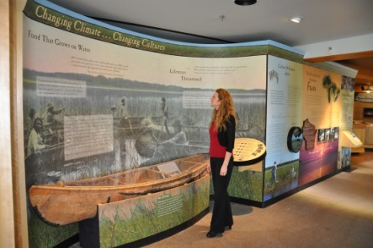
G-WOW Discovery Center and Guided Programs
This 200 sq. ft. interactive exhibit at the Northern Great Lakes Visitor Center in Ashland, WI explores the impacts of climate change on the sustainability of manoomin (wild rice) and the Ojibwe cultural practice of wild ricing as an indicator of how climate change is affecting people of all cultures. A 32-inch touch screen kiosk features the G-WOW curriculum in a condensed, interactive format to expand on the exhibit’s educational themes. Educator guided programs are available for school and youth groups.

G-WOW Field Courses for Youth & Adults
These customized experiences build confidence and ability to communicate and take action on climate change using the G-WOW model. Place-based climate change field investigations within the Lake Superior Chequamegon Bay region and tribal communities are integrated with training on using climate research. Climate change service learning strategies and tools support participants in developing outreach projects for the communities they serve. Traditional ecological knowledge, Ojibwe language, and cultural perspectives are infused. Learn more at: http://fyi.uwex.edu/nglvc/cool-coasts/

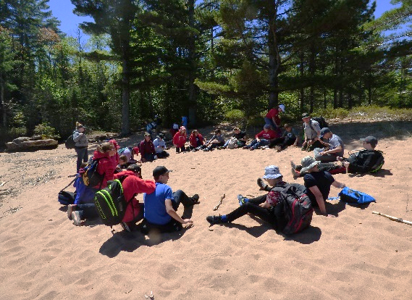

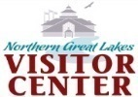
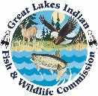
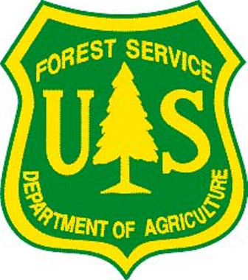
For more information on the G-WOW Initiative and programs please contact:
Cathy Techtmann, Environmental Outreach State Specialist, UW-Extension
Phone 715.561.2695 or email catherine.techtmann@ces.uwex.edu

61.

Miigwech (Thank you) to our Project Partners

